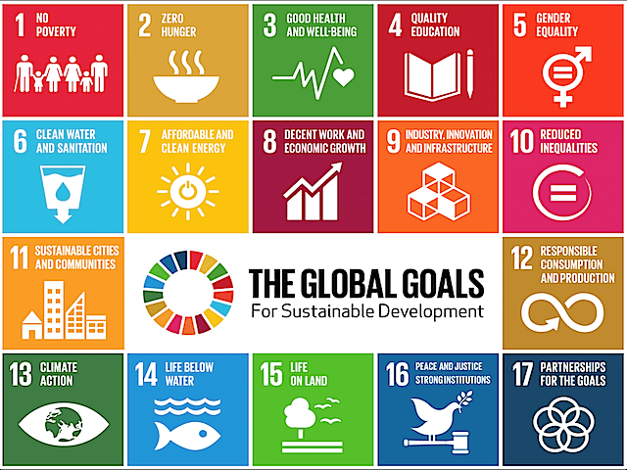
Strategic Planning and Assessment Council Goals for AY 2019-2020 (and beyond)
Sustainable Development as a Framework for Planning
Around Goal 4 of the United Nations Global Goals for Sustainable Development (UN SDGs), all other goals can work together to create a meaningful framework into which fits almost all aspects of our work across the institution. In accordance, develop a plan to use the UN SDGs to:

- Develop a shared knowledge/vocabulary around the SDGs.
- Support the campus’ development of a common understanding of the connections between the SDGs and the Strategic Plan Essential Initiatives and related institutional goals/priorities.
- Articulate campus-wide planning framework.
- Create planning checklist that connects unit planning to campus mission and Strategic Plan.
- Integrate sustainable development in our Middle States Self-Study (see #2 below).

Institutional Priorities to be Addressed in the Middle States Self-Study

New Paltz will pursue the following institutional priorities for this self-study:

- Nurture a learning environment founded on critical thinking, creativity, and the growth and sharing of knowledge.
- Cultivate sustainability in all its forms, including institutional, social, economic, and environmental sustainability.
- Forge community and enhance our commitment to diversity, equity, and inclusion.
- Increase accessibility of undergraduate and graduate education in the region.

Connect Planning Goals to Targets/Metrics/Assessments

Help academic and academic support units to connect their planning goals to broader campus goals and institutional targets/metrics/assessments (e.g., connecting institutional, general education (GE), and program goals to assessments).

Middle States

- Support the Standard 1 Working Group to fulfill its charge. The Council has representation from a wide range of schools and departments and a clear perspective of how the criteria in Standard 1 have been addressed in the Strategic Plan. One of the chairs of the MSCHE Standards Working Groups is a SPAC member, thereby increasing coordination and efficiency between Working Groups.

- Work with the Middle States Steering Committee and chairs to collect and interpret data for the self-study, paying close attention to how the criteria in Standard 1 have been addressed in the Strategic Plan.

